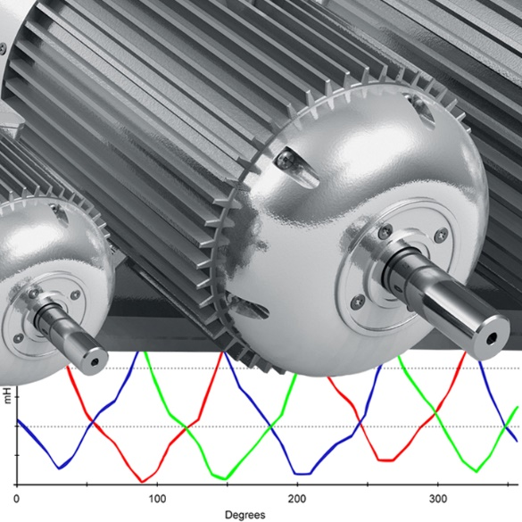

Electric Motor Testing Technician Certification
(EMTT)
Electric Motor Testing Technician Certification
Name: _________________________________________________
Background: Electric Motor Testing Technician (EMTT) – is a Certification for a person that’s basic function is to collect motor data safely and properly. It is essential that anyone that is assigned to collect “Energized” or “De-Energized” motor data have a level of knowledge deemed necessary to properly operate the motor test instrumentation, with regards to utilizing software to build databases, select and initiate motor tests and store the acquired data correctly. They shall be able to determine “good” vs. “bad data,” access panels safely, and override interlocks as necessary to interface equipment for testing. They shall have the basic electrical knowledge necessary to determine motor winding configurations and starting circuit types. They should be able to determine Current Transformer CT and Potential Transformer PT ratios.
Prerequisites: Because of the numerous types of circuits and electrical cabinet configurations, you should be familiar with the equipment at your facility, that you will be interfacing and testing.
Practical Factors and Prerequisites: | Supervisor Signature
Tester OEM Software
Database Construction
Tester Operation
OSHA 1910 and NFPA 70E Trained*
Electrical Safety for Interfacing Motor Circuits – Connections*
Familiarity With Starter Interlocks*
Familiarity and Ability to Read Motor Circuit Schematics*
Medium and High Voltage Connection Interface*

PLEASE NOTE: This document is provided as a guideline in establishing an effective Motor Testing and Power Quality Certification Program. It is inclusive of the recommended training, knowledge, practical factors, and experience deemed necessary for these Certifications.
It does not give specific guidelines for safety matters!
This document by no means represents all facets of safety or the ability to interface with electrical enclosures and interface equipment. The number and varied designs of these devices make it near impossible to include all the variances in a single document. It is incumbent upon the companies or individuals using this Certification document to learn the specifics for safety and the operation and interfacing of all of their equipment’s and test instruments. All plant-specific, local, state, and federal safety rules and regulations should be examined, understood and adhered to during any testing done.
*The Snell Group bears no liability or responsibility for or with respect to any safety or physical aspects of the operation of any equipment’s, interfacing or connections to any electrical circuits or damage or injury that may occur in the process of any procedure, operation, or maintenance action related to this Certification for any Power Quality or Motor testing related incidents. For the reasons stated above, there is no way to judge the individual’s safety practices that they follow, and it is the sole responsibility of the individuals and companies using these guidelines to assure accepted safety practices are always followed when doing motor testing. The Snell Group assumes no liability or responsibility, express or implied, when the individual conducts any testing.
Training and Knowledge Requirements: The Snell Group has a training curriculum specific to this Certification. It is recommended that you complete Our training or that of another competent training provider that covers all the knowledge requirements.
Knowledge Requirements | Supervisor Signature
Starting Circuit Configurations*
Wye Delta Start Configuration for De-Energized Testing*
Medium and High Voltage Connection Interface*
Potential Transformer Configuration and Determining Ratios
Current Transformer Configurations and Determining Ratios
Installed Equipment Operation and Effects
Determining Good Data and Data Confirmation
DC Theory - Series Circuits
DC Theory - Parallel Circuits
AC Theory - Series Circuits
AC Theory - Parallel Circuits
Correlate Motor Circuit to Series or Parallel

I attest that I have fully complied with the practical experience knowledge Requirements delineated in this Certification Document.
Typed or Printed Name: _______________________________________________
Signature: ____________________________________ Date: _________________
Supervisor Signature: ___________________________Date: ________________
To receive your Certificate:
Scan and submit this document to admin@thesnellgroup.com

