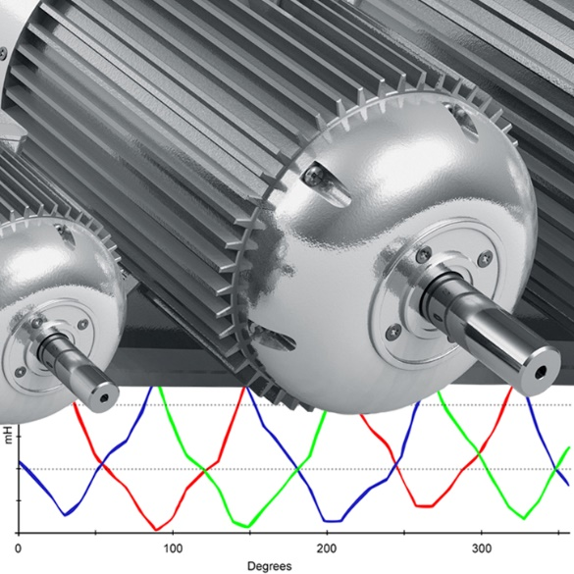

Electric Motor Testing Analyst Certification (EMTA)

Electric Motor Testing Analyst Certification
Name: ____________________________________________________________
Background: Electrical Motor Testing Analyst (EMTA) - Certification for a person to analyze energized and de-energized motor and motor circuit data. They will also be able to analyze electrical signature and current signature data, to determine motor failure mechanisms and driven equipment faults.
It is essential that anyone that is assigned to collect “Energized” or “De-Energized” motor data have a level of knowledge deemed necessary to properly operate the motor test instrumentation, with regards to utilizing software to build databases, select and initiate motor tests and store the acquired data correctly. They shall be able to determine “good” vs. “bad data,” access panels safely, and override interlocks as necessary to interface equipment for testing. They shall have the basic electrical knowledge necessary to determine motor winding configurations and starting circuit types. They should be able to determine Current Transformer CT and Potential Transformer PT ratios.
Prerequisites: If the Trainee for this Certification will be collecting test data, they shall also be Certified as an Electric Motor Test Technician Because of the numerous types of circuits and electrical cabinet configurations, you should be familiar with the equipment at your facility, that you will be interfacing and testing.
PLEASE NOTE: This document is provided as a guideline in establishing an effective Motor Testing and Power Quality Certification Program. It is inclusive of the recommended training, knowledge, practical factors, and experience deemed necessary for these Certifications.
It does not give specific guidelines for safety matters!
This document by no means represents all facets of safety or the ability to interface with electrical enclosures and interface equipment. The number and varied designs of these devices make it near impossible to include all the variances in a single document. It is incumbent upon the companies or individuals using this Certification document to learn the specifics for safety and the operation and interfacing of all of their equipment’s and test instruments. All plant-specific, local, state, and federal safety rules and regulations should be examined, understood and adhered to during any testing done.
*The Snell Group bears no liability or responsibility for or with respect to any safety or physical aspects of the operation of any equipment’s, interfacing or connections to any electrical circuits or damage or injury that may occur in the process of any procedure, operation, or maintenance action related to this Certification for any Power Quality or Motor testing related incidents. For the reasons stated above, there is no way to judge the individual’s safety practices that they follow, and it is the sole responsibility of the individuals and companies using these guidelines to assure accepted safety practices are always followed when doing motor testing. The Snell Group assumes no liability or responsibility, express or implied, when the individual conducts any testing.
Training and Knowledge Requirements: The Snell Group has a training curriculum specific to this Certification. It is recommended that you complete Our training or that of another competent training provider that covers all the knowledge requirements.
Practical Factors and Knowledge Requirements | Supervisor Signature
Tester OEM Software
Database Construction
Tester Operation
OSHA 1910 and NFPA 70E Trained*
Electrical Safety for Interfacing Motor Circuits – Connections*
Starting Circuit Configurations*
Wye Delta Start Configuration for De-Energized Testing*
Familiarity With Starter Interlocks*
Familiarity and Ability to Read Motor Circuit Schematics*
Medium and High Voltage Connection Interface*
Potential Transformer Configuration and Determining Ratios
Current Transformer Configurations and Determining Ratios
Installed Equipment Operation and Effects
Determining Good Data and Data Confirmation
DC Theory - Series Circuits
DC Theory - Parallel Circuits
AC Theory - Series Circuits
AC Theory - Parallel Circuits
Correlate Motor Circuit to Series or Parallel
AC Theory - RLC Circuits
Transformer Theory
Transformer Configurations
Transformer Turns Ratios
Transformer Losses
Operation and Use of Amp Probes / Current Transformers
Methods of Determining PT and CT Ratios
Understand Distribution Systems
Understand Grounding Systems and How They Can Affect Data
Understand Induction Motor Construction
Thorough Understanding of the Motor Rewind Process
Thorough Understanding of EASA Testing Process
Familiar with NEMA MG-1
Understand all Motor Nameplate Data

Practical Factors and Knowledge Requirements | Supervisor Signature
Familiar with Required Non-Nameplate Data
Understand Basic AC Generator Theory
Left-Hand Rule for Generators
Understand Operation of a Simple AC Generator
Understand Frequency and Period and how to Calculate
Understand the Operation of a Rotating Armature Alternator
Understand the Operation of a Field Armature Alternator
Familiarity with the different types of Generator Rotors
Familiarity with 3-Phase Alternators
Understand the effects of Alternator Frequency
Fundamentals of a Squirrel Cage Induction Motor
Understand Pole Polarity and the Left-Hand Rule for Coils
Understand Mutual Inductance as it Relates to Field Poles
Understand the Development of the Stator Rotating Field
Understand How Rotating Field Speed Changes
Understand Synchronous Speed vs. Slip and RPM
Understand Stator Field and Rotor Magnetic Field Interaction
Be Familiar with Torque vs. Slip
Understand Motor Torque and Current Curves
Understand Motor Current Components
Power Factor changes with Motor Loading
Discuss NEMA Design and Motor Start Current and Torque
Effective Program Establishment
Motor Tracking
Analyzing Motor Circuit Resistance
Analyzing Motor Circuit Impedance
Analyzing Capacitance to Ground
Power Factor Capacitors Individual Load and Bulk Correction
Analyzing Circuit Impedance
Familiarity with Surge Testing Capabilities and Impulse Waves
Understanding Pulse to Pulse Error Area Ratio
Familiarity With IEEE 43- Insulation Testing
Insulation Test Procedures and Considerations
Factors Effecting Insulation Tests
Timed Resistance Tests
Polarization Index Testing
PI Profile Analysis
Step Voltage Testing
AC and DC High Potential Testing
Rotor Influence Testing
Resistance, Inductance, and Impedance – Fault Isolation
Current Frequency Response
Warehouse Spares and Acceptance Testing
Motor Testing Program Implementation
Determining Criticality and Periodicity for De-energized Testing
Practical Factors and Knowledge Requirements | Supervisor Signature
New Motor Acceptance and Baseline Testing
Power Quality Anomaly Familiarity
Types of Generated Power and their Unique Impacts
Power Generation and Distributions Systems
Power Transmission and Sub Stations
Understand Linear and Non-linear Loads
High-Frequency Unidirectional and Oscillatory Events
Voltage Fluctuation
Voltage Sags, Swells, and Transient Over Voltage
Unbalanced Voltage - Causes and Effects
Unbalanced Current - Causes and Effects
Power Factor – Real Power, Apparent Power
Reactive Current Unbalance and Effects
Harmonics – Sources and Effects
Frequency Deviation
Ground Anomalies and Effects
NEMA Voltage Unbalance Parameters and De-rating
NEMA Harmonic Voltage Factor and De-rating
Procedures for Effective Energized Testing
Power Quality Data Analysis
AC Voltage Analysis – RMS, Peak, Crest Factor
Using Voltage Neutral to Identify Grounds
Current Analysis
Use of Current and Impedance Values to Localize Faults
Sequence Currents and Effects
IEEE 519, IEEE 1159
Understanding the Fast Fourier Transform FFT
Electrical and Current Signature Analysis
Purpose of FFT Windows
Linear and Logarithmic Spectral Displays
Analyzing In Rush Current and Various Starting Profiles
Understanding Various Types of Start Circuits and Analysis
In Rush and Load Current Correlation for Rotor Bar Anomalies
Correlating Start Peak and Transition Current to Isolate Faults
Use of Voltage and Current FFTs to Localize Faults
Determining Motor Speed Utilizing FFT
Calculating RPM and Frequency
Analyzing Rotor Anomalies
Calculating Field Pole Pass Frequency Sidebands - F_{PP}
Determining Rotor Fault Severity
Eight ways to Identify Rotor Anomalies Using EMT
Understanding Eccentricity and Causes
Calculating and Identifying Static and Dynamic Eccentricity
Estimating Number of Rotor Bars
FFT Analysis for Unbalance and Misalignment
Practical Factors and Knowledge Requirements | Supervisor Signature
Identifying Rotor Axial Movement
Calculating for Faults on Belt Driven Equipment
Calculating Blade Pass Frequencies
Gear Mesh Frequency Calculations
Using Current FFTs to Identify Bearing Faults
Safety Considerations for Electric Motor Testing

I attest that I have fully complied with the practical experience knowledge Requirements delineated in this Certification Document.
Typed or Printed Name: _______________________________________________
Signature: ____________________________________ Date: _________________
Supervisor Signature: ___________________________Date: ________________

To receive your Certificate:
Scan and submit this document to admin@thesnellgroup.com

